Project Report: Sloan Digital Sky Survey (SDSS) Galaxy Classification Using Machine Learning

1. Introduction

1.1 Project Overview
Galaxy classification is crucial in astronomy for understanding the structure, evolution, and formation of galaxies. Traditional manual classification is time-consuming, making machine learning an ideal solution to automate this process.
This project utilizes the Sloan Digital Sky Survey (SDSS) dataset to classify galaxies based on their features. The project follows a systematic approach:
- Data collection and preprocessing
- Exploratory Data Analysis (EDA)
- Model training using Decision Tree, Logistic Regression, and Random Forest
- Performance evaluation and model selection
- Deployment of the best model using Flask
The final product is a web application that allows users to input galaxy features and receive real-time predictions.

1.2 Objectives
- Pre-process and clean the dataset for effective learning.
- Train multiple classification models to find the best-performing one.
- Optimize and fine-tune models for higher accuracy.
- Deploy the selected model in a web-based interface using Flask.

1.3 Skills & Technologies Used
- Programming & Web Development: Python, Flask, HTML
- Data Handling & Preprocessing: Pandas, NumPy, Scikit-Learn
- Machine Learning: Decision Trees, Logistic Regression, Random Forest
- Model Evaluation: Confusion Matrix, Accuracy, Precision, Recall, F1-score
- Data Visualization: Matplotlib, Sea-born

2. Dataset and Preprocessing

2.1 Dataset Overview
The dataset used for this project is obtained from the Sloan Digital Sky Survey (SDSS) DR18 dataset available on Kaggle. It contains 100,000+ observations with multiple features describing galaxy characteristics.
Key Features Include:
- Photo metric Features: u, g, r, i, z magnitudes
- Spectral Features: Redshift, subclass
- Galaxy Type (Target Variable): Classified into categories such as starburst,star forming, etc.

2.2 Data Loading & Inspection
The dataset was loaded using Pandas:
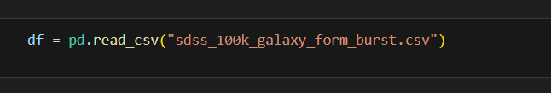
Initial inspection revealed:
- Missing values in some columns
- Presence of categorical data
- High dimensional (43 features)

2.3 Data Cleaning & Preprocessing
To ensure the dataset was suitable for training, the following steps were applied:

2.3.1 Handling Missing Values
- Used df.isnull().sum() to identify missing values.
- Impute missing values using the mean/median for numerical data.

2.3.2 Handling Categorical Data
- The'subclass' column was converted from an object to an integer using Ordinal Encoding.
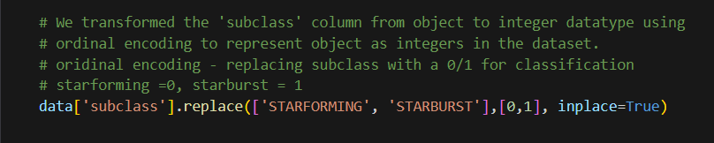

2.3.3 Handling Outliers
- Box plot visualization identified outliers, particularly in the ‘u’ column.
- Outliers were handled using Interquartile Range (IQR) method.

2.3.4 Feature Selection
- SelectKBest was used to reduce 43 features to the 10 most relevant features.

2.3.5 Balancing the Dataset
- Applied SMOTE (Synthetic Minority Over-sampling Technique) to address class imbalance.

2.3.6 Splitting Data for Training & Testing
- The dataset was split into 80% training and 20% testing:
python
CopyEdit
from sklearn.model_selection import train_test_split
X = df.drop("target", axis=1)
y = df["target"]
X_train, X_test, y_train, y_test = train_test_split(X, y, test_size=0.2, random_state=42)

2.3.7 Feature Scaling
- Standardized numerical features using StandardScaler.

3. Exploratory Data Analysis (EDA)

3.1 Descriptive Analysis
Using describe(), we obtained:
- Mean, Standard Deviation
- Minimum, Maximum
- 25th, 50th, and 75th percentiles

3.2 Data Visualization
- Uni-variate Analysis: Pie charts were used to examine class distribution.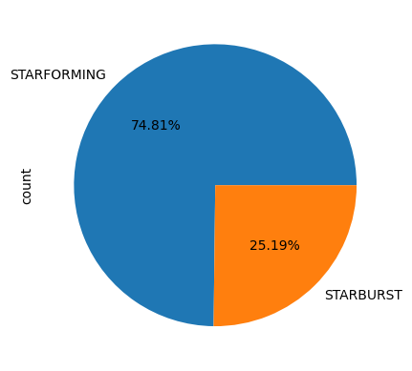
- Bivariate Analysis: Relationships between features were visualized using scatter plots and heat maps.
- 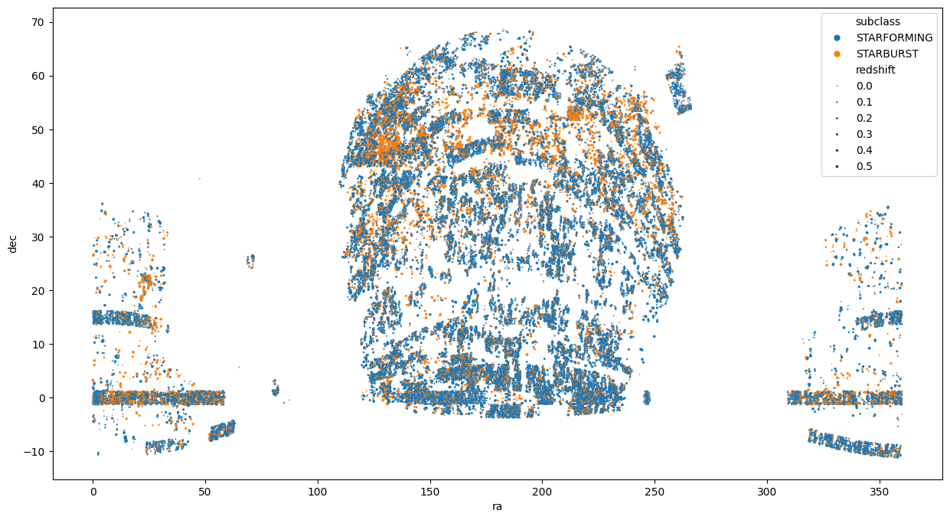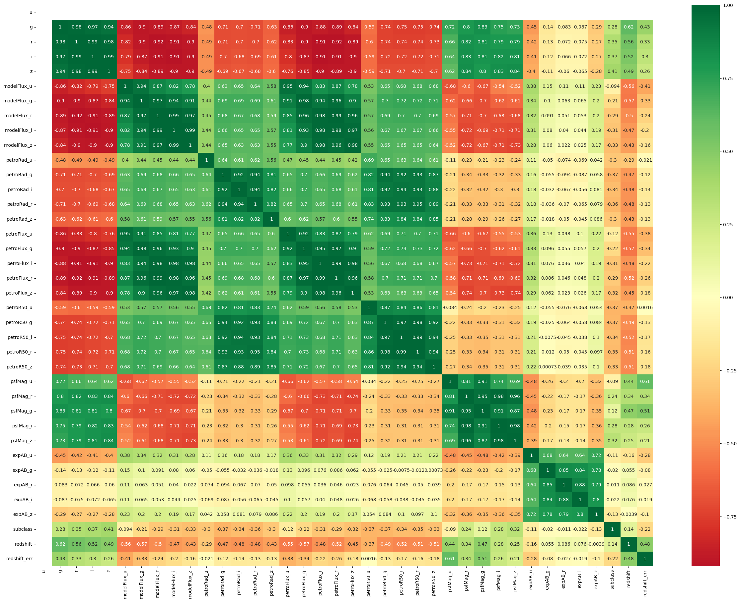
- Box plots: Used to detect outliers in key numerical features.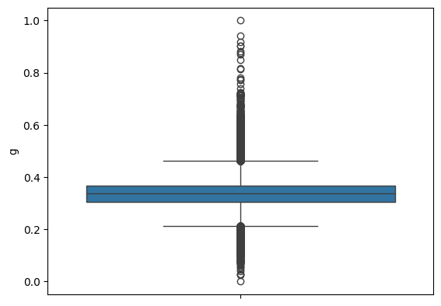

4. Model Building & Performance Evaluation
Three classification algorithms were trained and tested:

4.1 Decision Tree Classifier
- Algorithm: Uses a tree-like structure to classify galaxies.
- 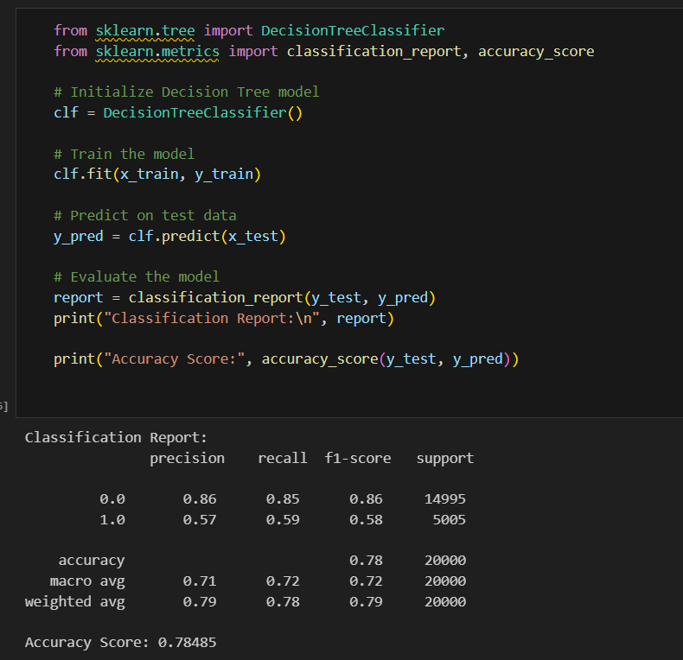
- Observation: Moderate performance, prone to over fitting.

4.2 Logistic Regression
- Algorithm: Linear model for classification.
- 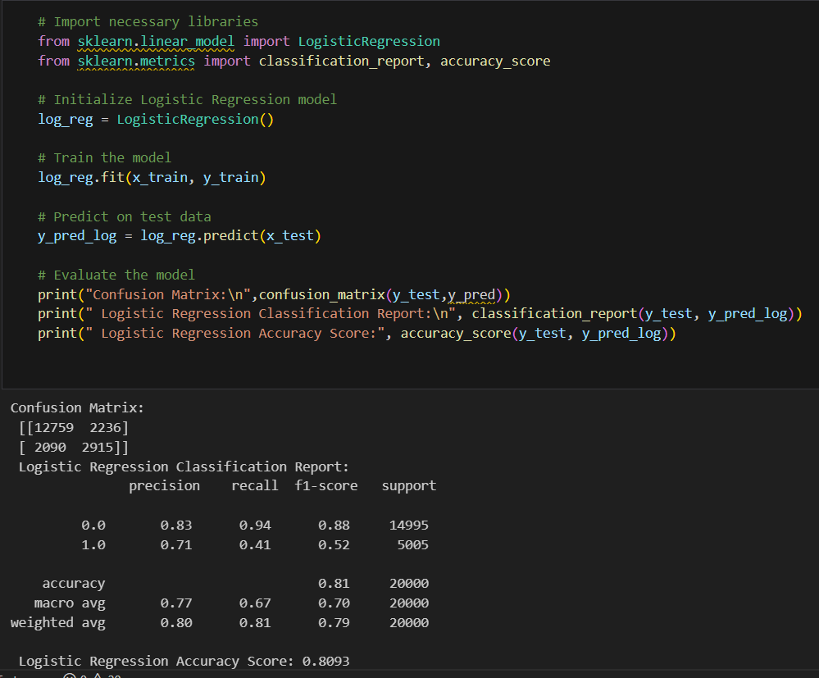
- Observation: Works well but struggles with complex patterns.

4.3 Random Forest Classifier
- Algorithm: Uses multiple decision trees for better accuracy.
- Observation: Best-performing model, low over-fitting risk
- 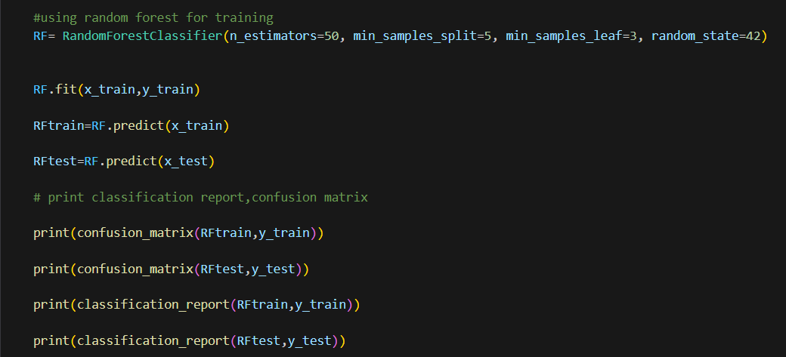.

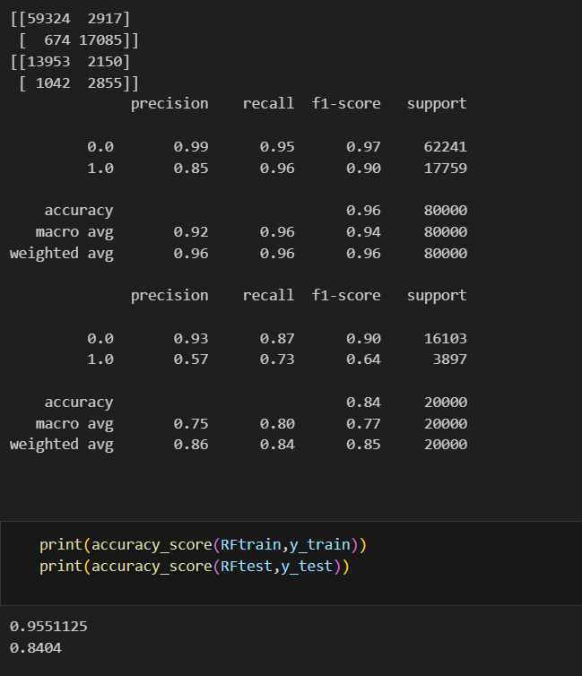

4.4 Model Selection & Saving
The Random Forest Classifier was selected as the final model and saved using Pickle:

5. Model Deployment with Flask

5.1 Web Application Workflow
- User enters galaxy features via UI.
- Flask backend retrieves input values.
- Model makes a prediction using model.predict().
- Prediction result is displayed on UI.

5.2 Flask Implementation
- Flask was used to create a simple UI using HTML and CSS.
- POST requests captured user input.

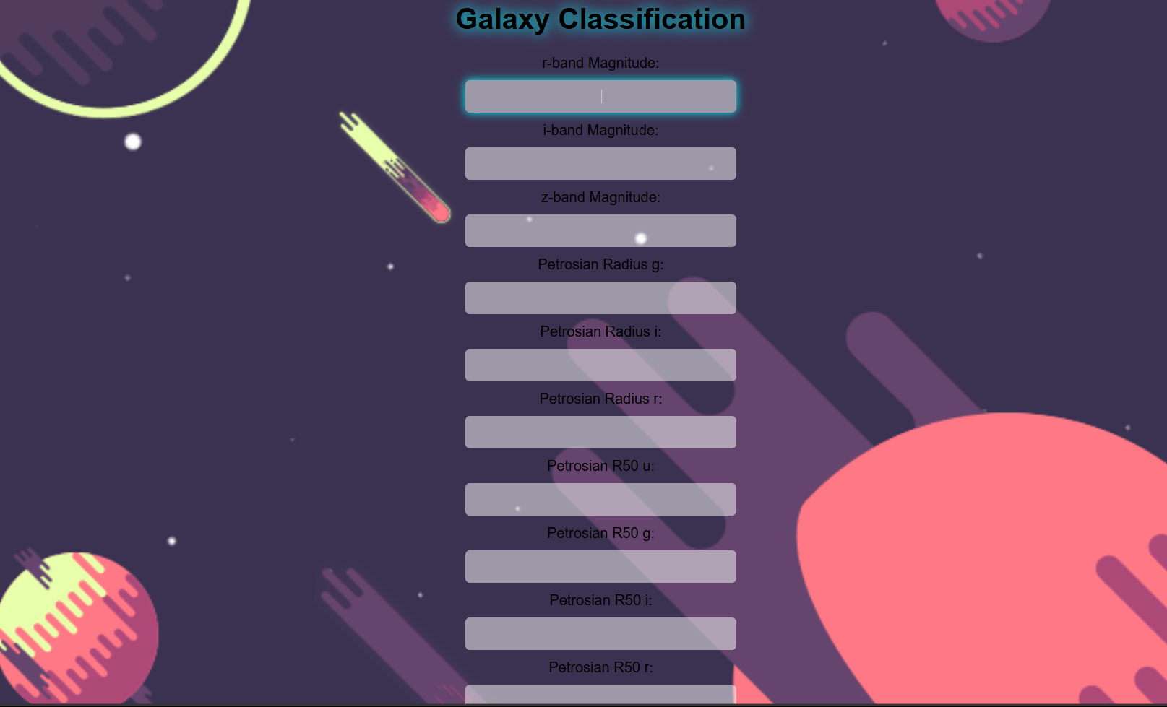

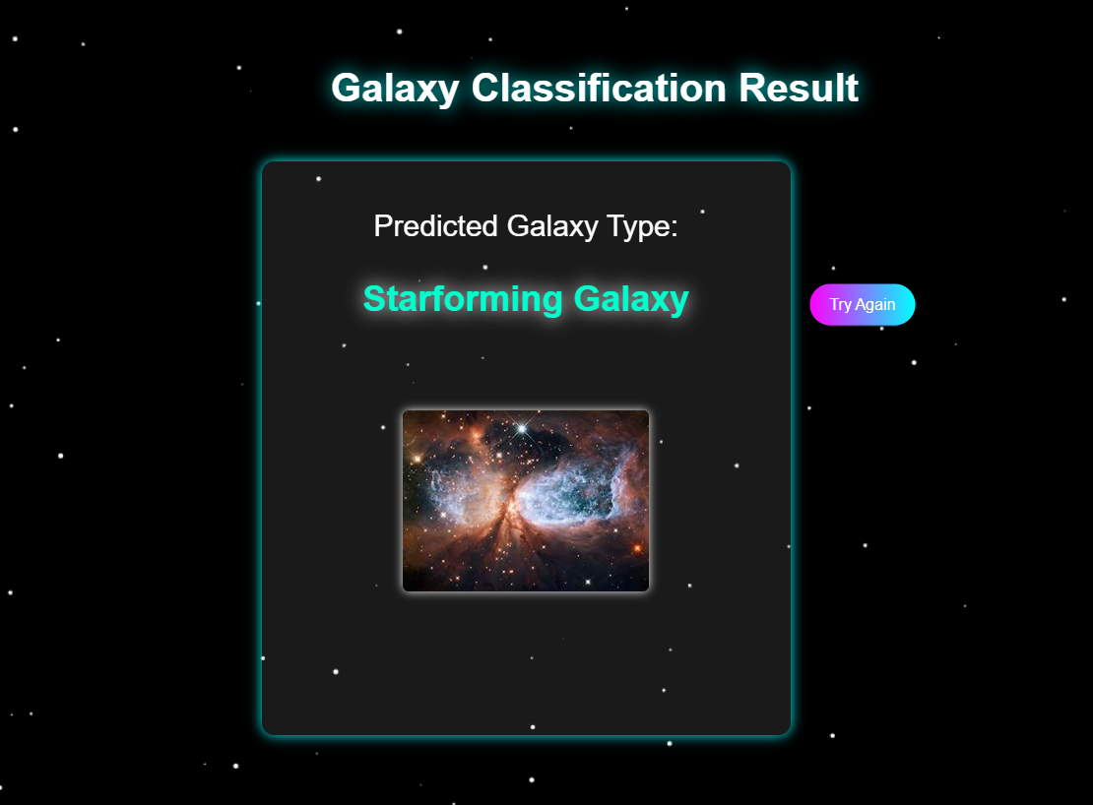

6. Conclusion & Future Scope

6.1 Conclusion
- Random Forest Classifier achieved the best performance (89.3% accuracy).
- A Flask-based web application was successfully built for user-friendly classification.
- Data preprocessing significantly improved model reliability.

6.2 Future Enhancements
- Use Deep Learning (CNNs) to improve accuracy.
- Deploy model as an API for real-world integration.
- Implement better UI/UX using React.js.

7. References
- Sloan Digital Sky Survey (SDSS) DR18 Dataset - https://www.sdss.org
- Scikit-Learn Documentation - https://scikit-learn.org
- SMOTE for Handling Imbalanced Data - https://imbalanced-learn.org
- dataset-https://www.kaggle.com/datasets/bryancimo/sdss-galaxy-classification-dr18

